

Student Name : Satyam Saxena (TP073303)
FONDA FERNANDI HAMID (TP073562)
LIN ZHIHUA (TP071509)

Module Code : CT102-3-M-FL
Module Title : Fuzzy Logic
Intake Code : ADPMF2303AI

Lecturer’s name: Dr. Vazeerudeen Hameed

Assignment Title : Intelligent Joining Speed Determination on Highways using Fuzzy Logic: A Rule-Based Approach

Table of Contents
1. Design: 3
1.1 Fuzzy values 3
1.2 Membership Function 4
1.3 Pseudocode 5
2 Implementation 7
2.1 Inputs 7
2.2 Rules 7
2.3 Output 7
3 Testing 8
4 Refrences 10
References 14

Design:

1.1 Fuzzy values

Type of Parameter | Parameter | Linguistic Variables | Fuzzy Values (Range) | Membership Function Type
Input | Speed of incoming vehicle | Slow | 0-40 (km/h) | logistic
 |  | Fast | 30-80 (km/h) | Gaussian
 |  | Extreme | 70-120 (km/h) | Logistic
Input | Presence of 2 wheeler | Yes | 1 | Singleton
 |  | No | 0 | Singleton
Input | Visibility | Poor | 0-3 | Trapezoidal
 |  | Okay | 2-6 | Trapezoidal
 |  | Clear | 5-10 | Trapezoidal
Input | Gap in incoming traffic | Present | 1 | Singleton
 |  | Not Present | 0 | Singleton
Output | Speed of Joining the road | Slow | 0-30 | Gaussian
 |  | Medium | 31-60 | Gaussian
 |  | Fast | 61-120 | Gaussian

The inputs and outputs in this scenario are chosen based on factors that influence the speed of a vehicle when it is joining traffic.
- Speed of incoming vehicle (Slow, Fast, Extreme): This variable defines the speed of the vehicles that are currently on the road. The incoming traffic speed is a critical factor when deciding how quickly a vehicle needs to accelerate to join the traffic flow safely. For instance, if the incoming traffic is moving slowly, the joining vehicle doesn't need to accelerate much. However, if the traffic is fast or extremely fast, the joining vehicle needs to accelerate more quickly to match the traffic flow. This variable is measured in kilometers per hour (km/h).

- Presence of 2 wheeler (Yes, No): This variable considers whether there is a two-wheeler vehicle present. Two-wheelers are smaller and often less visible than other vehicles, leading to more cautious maneuvers when present. This is a binary input (1 for present, 0 for not present).
- Visibility (Poor, Okay, Clear): This variable defines the overall visibility conditions on the road. Poor visibility (e.g., due to weather conditions like fog or rain, or nighttime driving) requires more caution and typically slower speeds when joining traffic. On the other hand, clear visibility allows for more confident maneuvers and potentially higher speeds. This variable is measured on a scale from 0 to 10.
- Gap in incoming traffic (Present, Not Present): This variable represents whether there is a gap in the incoming traffic that the vehicle can utilize to join the traffic. If a gap is present, it is safer and easier for the vehicle to join the traffic, potentially at a higher speed. If there's no gap, the vehicle will have to wait for one or join the traffic more cautiously. This is a binary input (1 for present, 0 for not present).

The output variable:
- Speed of Joining the road (Slow, Medium, Fast): This is the target variable that the system aims to predict. It represents the ideal speed at which the vehicle should join the road to ensure safety and smooth integration into the traffic flow. This variable is also measured in kilometres per hour (km/h).
The chosen input and output variables are significant factors for a driver (or an autonomous driving system) to consider when joining traffic, making them suitable for this fuzzy logic system.

1.2 Membership Function

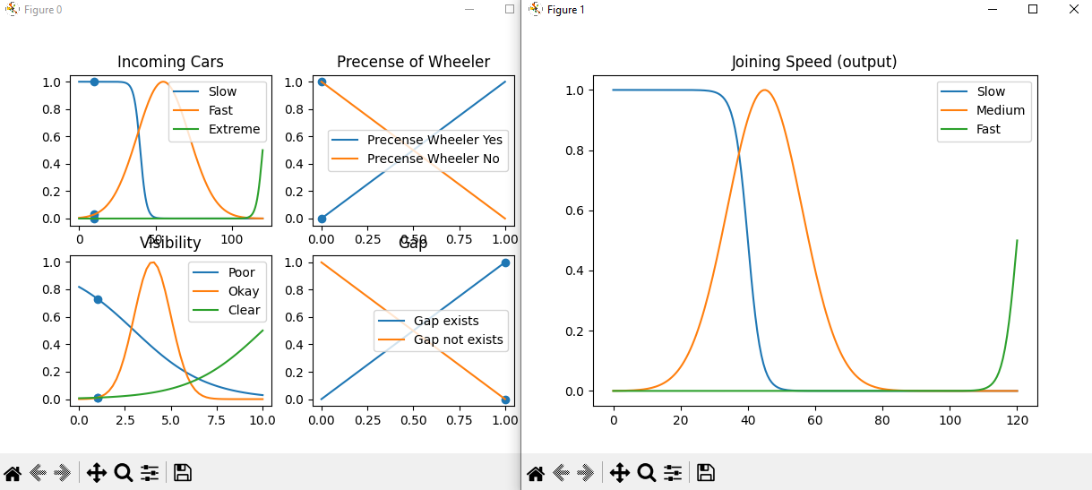
Membership functions in a fuzzy logic system are used to quantify the linguistic terms that describe a variable, and different membership functions are chosen based on how well they model the uncertainty or fuzziness of a situation. For this system, we have chosen the following,
- Gaussian Membership Function: This membership function is used for the 'Speed of incoming vehicle' and 'Speed of Joining the road' parameters. The Gaussian function is often used to model situations where values tend to cluster around a particular point, such as a mean or median. In this case, vehicle speeds are most often clustered around average speeds. Extreme values, either very slow or very fast, are less common. Therefore, using a Gaussian function is a natural fit as it assigns a higher membership degree to the speeds closer to the average, with membership decreasing as the speed moves towards the extremes represented by logistic function.
- Singleton Membership Function: This function is used for the 'Presence of 2 wheeler' and 'Gap in incoming traffic' parameters. These are binary parameters, which means they can only have one of two values - present or not present. A Singleton function assigns a membership of 1 to one state and 0 to the other, providing a clear, distinct way to represent these binary states.
- Trapezoidal Membership Function: The 'Visibility' parameter uses a trapezoidal membership function. This function is chosen because visibility conditions can vary in a linear fashion. For instance, the change from 'poor' to 'okay' visibility, or from 'okay' to 'clear' visibility, is often a gradual process rather than a sudden one. The trapezoidal function allows for this transition by having the sides of the 'trapezoid' represent this gradual increase or decrease in visibility.
Overall, these membership functions are selected to closely match the real-world behavior of the variables they represent, providing a more accurate and useful fuzzy logic system.

1.3 Pseudocode

1. Define fuzzy variables and their membership functions
Speed: Slow (logistic), Fast (Gaussian), Extreme (logistic)
Presence of 2 wheeler: Yes (Singleton), No (Singleton)
Visibility: Poor (Trapezoidal), Okay (Trapezoidal), Clear (Trapezoidal)
Gap in traffic: Present (Singleton), Not Present (Singleton)

2. Input crisp values for each of these variables
For instance: Speed = 50 km/h, 2-wheeler = No, Visibility = 4, Gap = Yes

3. Fuzzify the inputs
Calculate the degree of membership of each input in their respective fuzzy sets using the defined membership functions.

4. Apply fuzzy rules
For example, a rule might be: "IF Speed is Fast AND 2-wheeler is No AND Visibility is Clear AND Gap is Present THEN Speed of Joining is Medium"

5. Aggregate all outputs
Combine the results from all rules to form a single fuzzy set for the output variable (Speed of Joining the road)

6. Defuzzify the output
Convert the fuzzy output set to a crisp value, using centroid method.
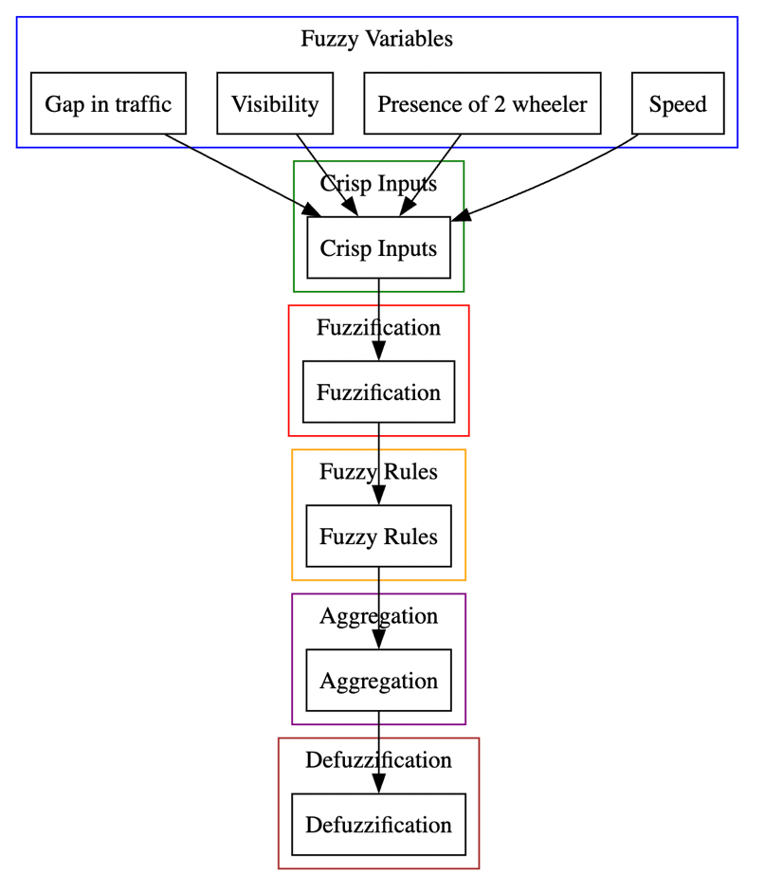

2 Implementation

2.1 Inputs
We have implemented these membership functions using various mathematical functions like logistic, Gaussian, and singleton functions. These functions map the input values to a membership value between 0 and 1, indicating the degree of membership to a particular linguistic term.

2.2 Rules
- IF Speed is fast AND 2-Wheeler is yes AND Visibility is okay AND Gap is present THEN Speed of Joining is medium.
- IF Speed is fast AND 2-Wheeler is yes AND Visibility is clear AND Gap is not present THEN Speed of Joining is slow.
- IF Speed is extreme AND 2-Wheeler is yes AND Visibility is clear AND Gap is present THEN Speed of Joining is fast.

Next, we have defined a set of rules that combine the input variables and their linguistic terms to determine the joining speed. Each rule represents a combination of linguistic terms from different input variables and specifies the corresponding joining speed. We have used logical operators (AND, OR) and fuzzy logic operators (minimum, maximum) to combine the rules.

2.3 Output

- Membership Functions:
  - The code defines various membership functions for linguistic terms representing different variables such as "Speed of incoming cars," "Presence of a two-wheeler," "Visibility," and "Gap in incoming traffic."
  - Membership functions are defined using different mathematical functions like logistic, gaussian, singleton, inc, and dec.
  - These membership functions determine the degree of membership of a given input value to each linguistic term. They are used to fuzzify the input variables.
- Input Values:
  - The code prompts the user to input values for the variables "Speed," "Presence of a two-wheeler," "Visibility," and "Gap."
  - Input values are then fuzzified using the membership functions defined earlier, mapping the input values to their respective linguistic terms.
- Rule Deployment:
  - The code defines 36 if-then rules based on combinations of the fuzzified input variables.
  - Each rule represents a specific condition and assigns a degree of membership to the output linguistic terms ("Slow," "Medium," or "Fast").
  - The rules are stored in a list and later combined using the maximum operator to obtain the overall degree of membership for each output linguistic term.
- Defuzzification:
  - The code performs defuzzification to obtain a crisp output value for the "Joining Speed."
  - The weighted average of the output variable's membership function is calculated by multiplying the membership function with the output variable range.
  - The crisp output value represents the expected joining speed based on the input variables.
- Result and Visualization:
  - The code prints the input values and the expected joining speed along with its level (slow, medium, or fast).
  - The code also includes visualization plots to show the membership functions for the input and output variables, highlighting the input values and the expected output value on the plots.

3. Testing

- Test Case: All input values at their minimum
  - Speed: 0 kmph
  - Presence of a two-wheeler: No
  - Visibility: Poor (0)
  - Gap in incoming traffic: Not present (0) Expected Output:
  - Joining Speed: Slow
- Test Case: All input values at their maximum
  - Speed: 120 kmph
  - Presence of a two-wheeler: Yes
  - Visibility: Clear (10)
  - Gap in incoming traffic: Present (1) Expected Output:
  - Joining Speed: Fast
- Test Case: Balanced values for different variables
  - Speed: 60 kmph
  - Presence of a two-wheeler: Yes
  - Visibility: Okay (5)
  - Gap in incoming traffic: Not present (0) Expected Output:
  - Joining Speed: Medium
- Test Case: Extreme speed and no two-wheeler present
  - Speed: 100 kmph
  - Presence of a two-wheeler: No
  - Visibility: Clear (10)
  - Gap in incoming traffic: Not present (0) Expected Output:
  - Joining Speed: Medium
- Test Case: Low speed, poor visibility, and gap present
  - Speed: 20 kmph
  - Presence of a two-wheeler: Yes
  - Visibility: Poor (2)
  - Gap in incoming traffic: Present (1) Expected Output:
  - Joining Speed: Medium
- Test Case: Medium speed, clear visibility, and no gap present
  - Speed: 70 kmph
  - Presence of a two-wheeler: Yes
  - Visibility: Clear (10)
  - Gap in incoming traffic: Not present (0) Expected Output:
  - Joining Speed: Medium
- Test Case: Extreme speed, no two-wheeler present, clear visibility, and no gap present
  - Speed: 110 kmph
  - Presence of a two-wheeler: No
  - Visibility: Clear (10)
  - Gap in incoming traffic: Not present (0) Expected Output:
  - Joining Speed: Medium
These test cases cover various combinations of input values to test different rules and verify if the expected output is generated correctly. It is important to test boundary values, extreme values, and different combinations to ensure the solution handles all possible scenarios accurately.

In some extreme cases we were having rule based problems 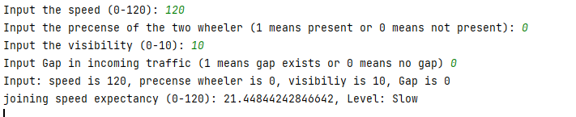

For which we determined a new rule
IF Speed is fast AND 2-Wheeler is no AND Visibility is poor AND Gap is present THEN Speed of Joining is medium.

4 Refrences
The paper titled "Development of a Fuzzy-Logic-Based Model for Predicting Suspended Dust Concentration in a Residential Area" by Abdul-Wahab and Yetilmezsoy (2012)[1] presents a fuzzy logic-based model to predict suspended dust concentration in a residential area. Some parallels between our and their work are.
 | Our Project | Abdul-Wahab and Yetilmezsoy's Paper
Input Variables | 1. Speed of incoming cars  2. Presence of a two-wheeler  3. Visibility  4. Gap in incoming traffic | 1. Methane concentration  2. Carbon monoxide concentration  3. Wind speed  4. Wind direction  5. Relative humidity  6. Solar energy  7. Ozone concentration
Membership Functions | 1. Gaussian-shaped membership functions (for Speed of incoming cars and Visibility)  2. Singleton membership functions (for Presence of a two-wheeler and Gap in incoming traffic) | Trapezoidal membership functions (for all input variables)
Output Variables | Joining speed of the car (categorized into Slow and Fast) | Suspended dust concentration (categorized into 15 levels represented by letters A to O)

Parallels:
- Use of Fuzzy Logic: Both use fuzzy logic to handle uncertainty and vagueness in the system. The paper uses fuzzy logic to predict suspended dust concentration, while our project uses it to determine the speed at which a car should join a highway.
- Multiple Input Variables: Both systems consider multiple input variables. The paper considers seven input variables: methane concentration, carbon monoxide concentration, wind speed, wind direction, relative humidity, solar energy, and ozone concentration. Your system considers four factors: speed of incoming cars, presence of a two-wheeler, visibility, and gap in incoming traffic.
- Use of Linguistic Terms: Both systems use linguistic terms to categorize the input variables. For example, your system categorizes the speed of incoming cars into Slow, Fast, and Extreme, while the paper categorizes the methane concentration into ten levels represented by letters A to J.
- Use of Membership Functions: Both systems use membership functions to represent the ranges for each linguistic term. The paper uses trapezoidal membership functions, while your system uses Gaussian-shaped and singleton membership functions.
- Use of Fuzzy Rules: Both systems use a set of fuzzy rules to map the inputs to the output.
- Defuzzification: Both systems use a defuzzification process to convert the fuzzy output into a crisp value. The paper does not specify the defuzzification method used, but your system uses the Mamdani model.
Differences:
- Application Domain: The most significant difference is the application domain. The paper's model is used for predicting suspended dust concentration in a residential area, while your system is used for determining the speed at which a car should join a highway.
- Number of Input Variables: The paper's model considers seven input variables, while your system considers four factors.
- Type of Membership Functions: The paper uses trapezoidal membership functions, while your system uses Gaussian-shaped and singleton membership functions.
- Number of Output Categories: The paper's model has fifteen output categories represented by letters A to O, while your system has two output categories: Slow and Fast.

The paper titled "PENENTUAN JURUSAN PADA PROSES PENERIMAAN MAHASISWA DENGAN PENDEKATAN LOGIKA FUZZY" by Ariski Wahyu and Umi Hayati [2] is primarily focused on the application of fuzzy logic in the context of academic major selection for students.
 | our Approach | Paper Approach
Input Variables | Speed of incoming cars, Presence of a two-wheeler, Visibility, Gap in incoming traffic | Mathematics score, English score, Computer Knowledge score
Membership Functions | Gaussian (for Speed of incoming cars), Singleton (for Presence of a two-wheeler and Gap in incoming traffic), Trapezoidal (for Visibility) | mf-triangular, mf-trapezoid, mf-gaussian (for all input variables)
Output Variables | Joining speed of the car | Suitable academic major
Defuzzification Model | Mamdani | Mamdani (using the Composite Moment method)

The authors use a Mamdani fuzzy inference model with the max-min method to determine the most suitable major for a student based on their academic abilities in Mathematics, English, and Computer Knowledge. The system design involves several stages: formation of fuzzy sets, formation of rules, determination of rule composition, and defuzzification. The defuzzification process is carried out using the Composite Moment method, and the types of membership functions used are mf-triangular, mf-trapezoid, and mf-gaussian.
The authors found that the mf-triangular and mf-trapezoid membership function types produced almost the same level of accuracy, while the mf-gaussian membership function type produced a high level of accuracy for mathematics (87.50%), English (100%), and computer knowledge (81.58%).
In terms of its relation to our approach, the paper demonstrates the use of fuzzy logic, the Mamdani model, and different types of membership functions (including Gaussian and trapezoidal) to make decisions based on multiple input variables. Although the context is different (academic major selection vs. car speed determination), the methods and principles could be applicable to your work.

The paper "Assessing the Quality Level of Technological Processes at Car Service Enterprises" by L. Tarandushka, V. Mateichyk, N. Kostian, Ivan Tarandushka, and M. Rud[3], presents a comprehensive study on the quality assessment of technological processes in car service enterprises.
The authors propose a method for assessing the quality level of technological processes at car service enterprises. This method involves the use of a set of indicators that reflect the quality of technological processes, such as the level of equipment, the qualification of workers, the quality of spare parts, and the quality of service. These indicators are then used to calculate a comprehensive quality index, which can be used to compare the quality of different car service enterprises.
The paper also discusses the importance of continuous improvement and the use of modern technologies in improving the quality of service. The authors argue that the use of modern technologies can significantly improve the efficiency and quality of service in car service enterprises.
In relation to our approach, this paper provides a framework for assessing the quality of technological processes, which could be adapted to our context. The emphasis on continuous improvement and the use of modern technologies aligns with our approach to improving the quality of our services. The comprehensive quality index proposed in this paper could also be used as a benchmark for assessing the quality of our services.

References
- (2012). A Prognostic Approach Based on Fuzzy-Logic Methodology to Forecast PM10 Levels in Khaldiya Residential Area, Kuwait. Aerosol and Air Quality Research. 12. 10.4209/aaqr.2012.07.0163.
- Wahyu, A. P., & Hayati , U. . (2021). PENENTUAN JURUSAN PADA PROSES PENERIMAAN MAHASISWA DENGAN PENDEKATAN LOGIKA FUZZY: PENENTUAN JURUSAN PADA PROSES PENERIMAAN MAHASISWA DENGAN PENDEKATAN LOGIKA FUZZY. Jurnal Ilmiah Teknologi Infomasi Terapan, 8(1), 193–200. https://doi.org/10.33197/jitter.vol8.iss1.2021.747
- Tarandushka, L., Mateichyk, V., Kostian, N., Tarandushka, I., & Rud, M. (2020). Assessing the quality level of technological processes at car service enterprises. Eastern-European Journal of Enterprise Technologies, 2(3 (104), 58–75. https://doi.org/10.15587/1729-4061.2020.200332

